Exercises on High Voltage Engineering (April 25, 2024)

Lecture 8: Liquid and Solid Dielectrics (3)

Yuanxiang Zhou

**Supplementary Exercise 1:** There is a capacitor with the capacitance *C*=2000 pF and tan*δ*=0.01, with the insulation resistance of 2000 MΩ under DC, find:

1. Power loss at 100 kV (RMS) under power frequency;

2. Loss at 100 kV DC, and its ratio to the loss under AC;

3. Equivalent resistance in the parallel equivalent circuit of dielectric losses under AC, and its ratio to the DC insulation resistance.

**Supplementary Exercise 2:** When measuring the *ε*r and tan*δ* of polyethylene, the sample is the same as when measuring *ρ*V, as shown in the figure. The thickness of the flat sample is 2 mm, and aluminum foil electrodes can be attached with Vaseline, with a total Vaseline layer thickness of about 0.05 mm. The electrical properties of polyethylene are: *ε*r = 2.3, tan*δ* = 2×10-4. If Vaseline with *ε*r = 2.2 and tan*δ* = 2×10-3 is used and it is dirty, causing increased losses, what measurement error does this lead to?

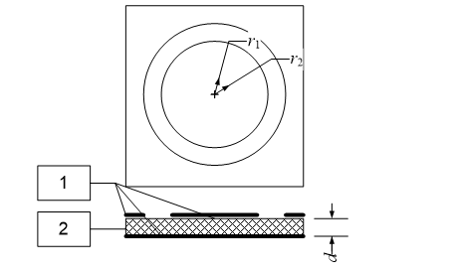

1 - Aluminum foil electrode; 2 - Dielectric

**Supplementary Exercise 3:** Assume an indoor bushing uses wound insulation and a conductor rod (radius *r*1 = 1 cm), with the same inner radius of the insulation as the conductor radius, an outer radius *r*2 = 7 cm, and a flange length *l*f = 20 cm. Power frequency voltage is applied to the bushing.

1. Where might sliding discharge occur first in this insulation structure?

2. To improve the performance of the bushing, 5 layers of concentric cylindrical electrode plates are installed inside. The setting method is to make the thickness of each insulation layer equal, and the potential difference between the electrodes of each layer of insulation is also equal. Try to calculate the length and radius of these plates (the edge effects of the electrodes are ignored).